Cloud Intake Process

Bryan Nieznajko

9/10/2020

Parallel

* Request MS ID
* Once MS ID is created, create Primary and Secondary ENT IDs **(Bryan Nieznajko will create ENT IDs for you once MS ID is created)**
* Request RSA token
* Request Citrix access and/or Optum laptop with VPN
  + Optum laptop/VPN is a better user experience for managing Azure portal
  + You must have access to Optum/UHG core network for authentication into Azure portal using secondary ENTID – See “Access Azure Portal” section

Sequential

* Create Solution Intent documentation, including network and architecture diagrams, security architecture, end users, test plan, timelines, etc.
* Complete Work Intake (Change Request) form
* Create ASK ID – need following information **(Bryan Nieznajko will create ASK ID and get GL account associated to it – need GL)**

* Request Finance group to assign GL code to ASK ID (Assignment occurs overnight, once GL code is associated to ASK ID) for subscription billing
* Create intake.md file from Solution Intent Document **(Bryan Nieznajko)**
* Create GitHub repository for project **(Bryan Nieznajko)**
* Upload all documentation to GitHub repo **(Bryan Nieznajko)**
* Create ServiceNow ticket for Azure non-prod subscription (using URL for github repo/intake.md file as reference) **(Bryan Nieznajko)**

Health Care Cloud Intake Overview

**Access Azure Portal**

Complete the steps below for access to [Public Azure](https://portal.azure.com/) within UHG's tenant.

**Steps**

1. [Request AzureAccess global group with MSID](https://commercialcloud.optum.com/docs/getting-started/access-azure-portal/#request-azure-access-group-membership).
2. [Create your first (primary) ENTID](https://commercialcloud.optum.com/docs/getting-started/access-azure-portal/#request-primary-and-secondary-ids)
3. [Create your second (secondary) ENTID](https://commercialcloud.optum.com/docs/getting-started/access-azure-portal/#request-primary-and-secondary-ids)
   * This secondary id is used to access Azure, e.g. [mgrose3@entid.optumhub.net](mailto:mgrose3@entid.optumhub.net)
4. [Login to the azure portal using your full secondary ENTID](https://portal.azure.com/).

Optional (Not Required for DCE):

1. [Request Global Group Membership to Your Subscription](https://commercialcloud.optum.com/docs/getting-started/access-azure-portal/#request-global-group-membership-to-your-subscription)

**Request Azure Access Group Membership**

Your primary **MS** ID must be added to the MS global group AzureAccess.

* Click on *Secure Home Page > Primary Windows Account > Add Group Membership* and fill out the form as shown below: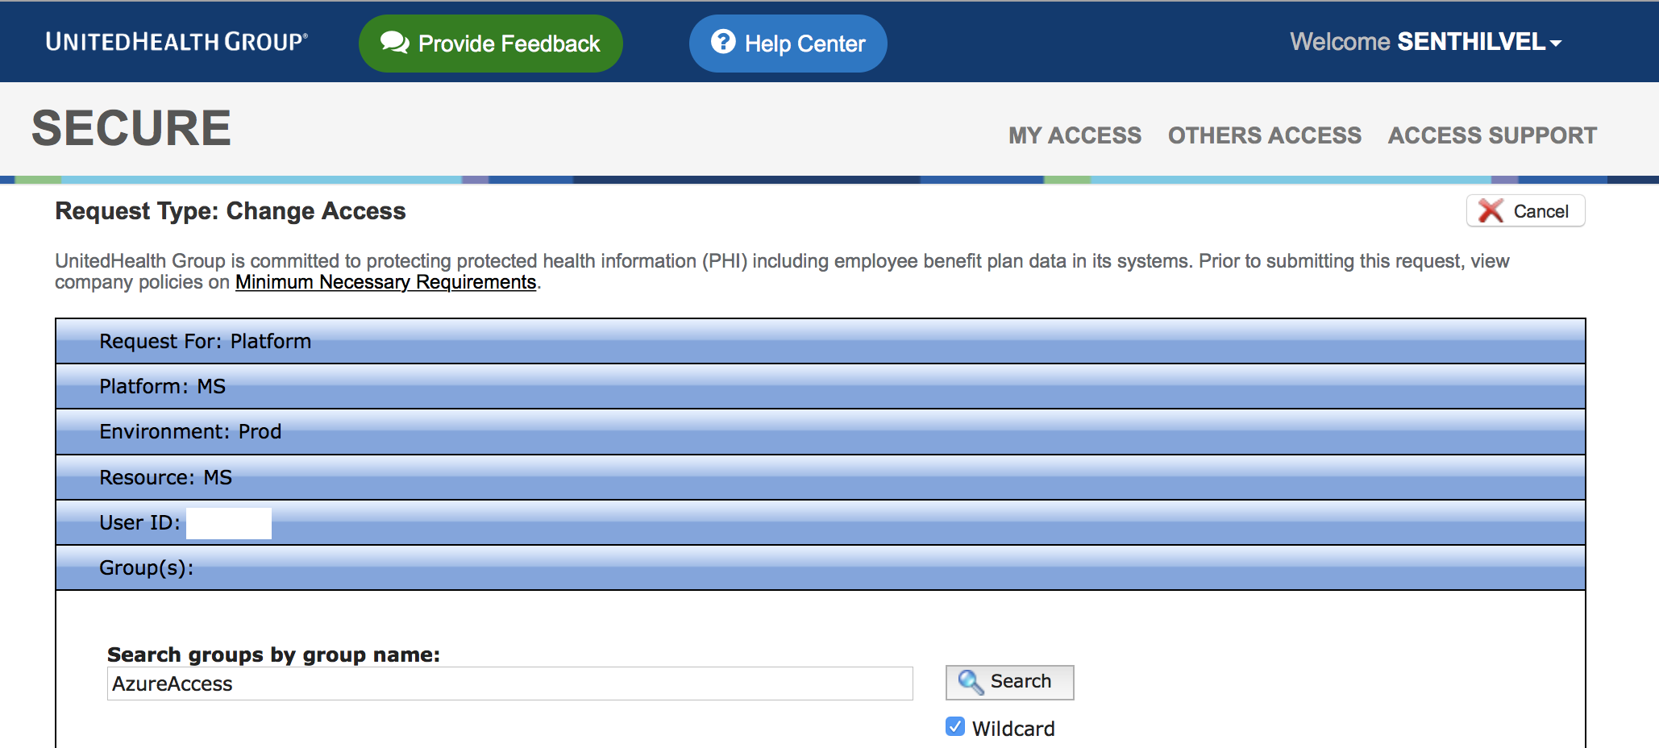
* Provide business justification and submit the request.

**Request Primary and Secondary IDs**

This process assumes you don't have a Primary or Secondary ENTIDOPTUMHUB User ID.

* Log in to secure.uhc.com.
* Navigate to *Request New Access*. 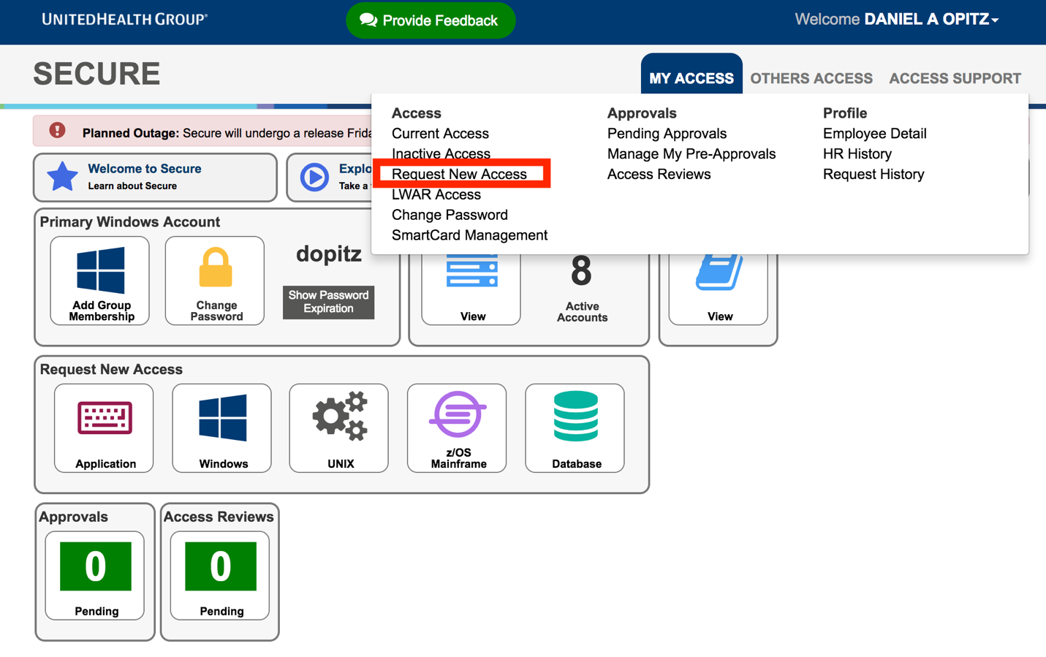
* Choose request access for *Platform* and click next. 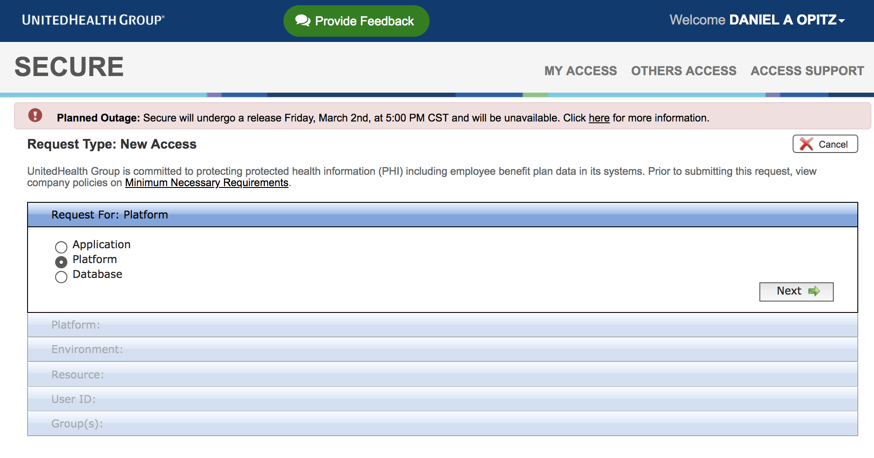
* Choose *Windows* and *ENTIDOPTUMHUB* on the Platform page. 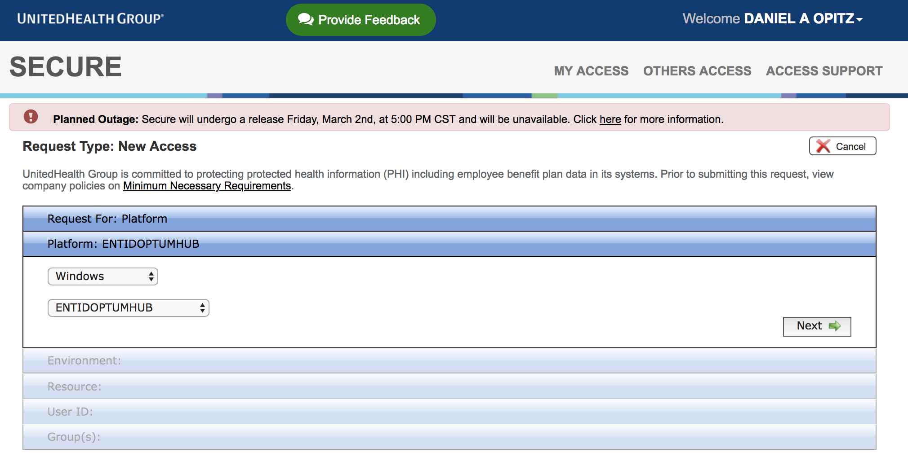
* Proceed to the User ID page and select *Create New User ID*. 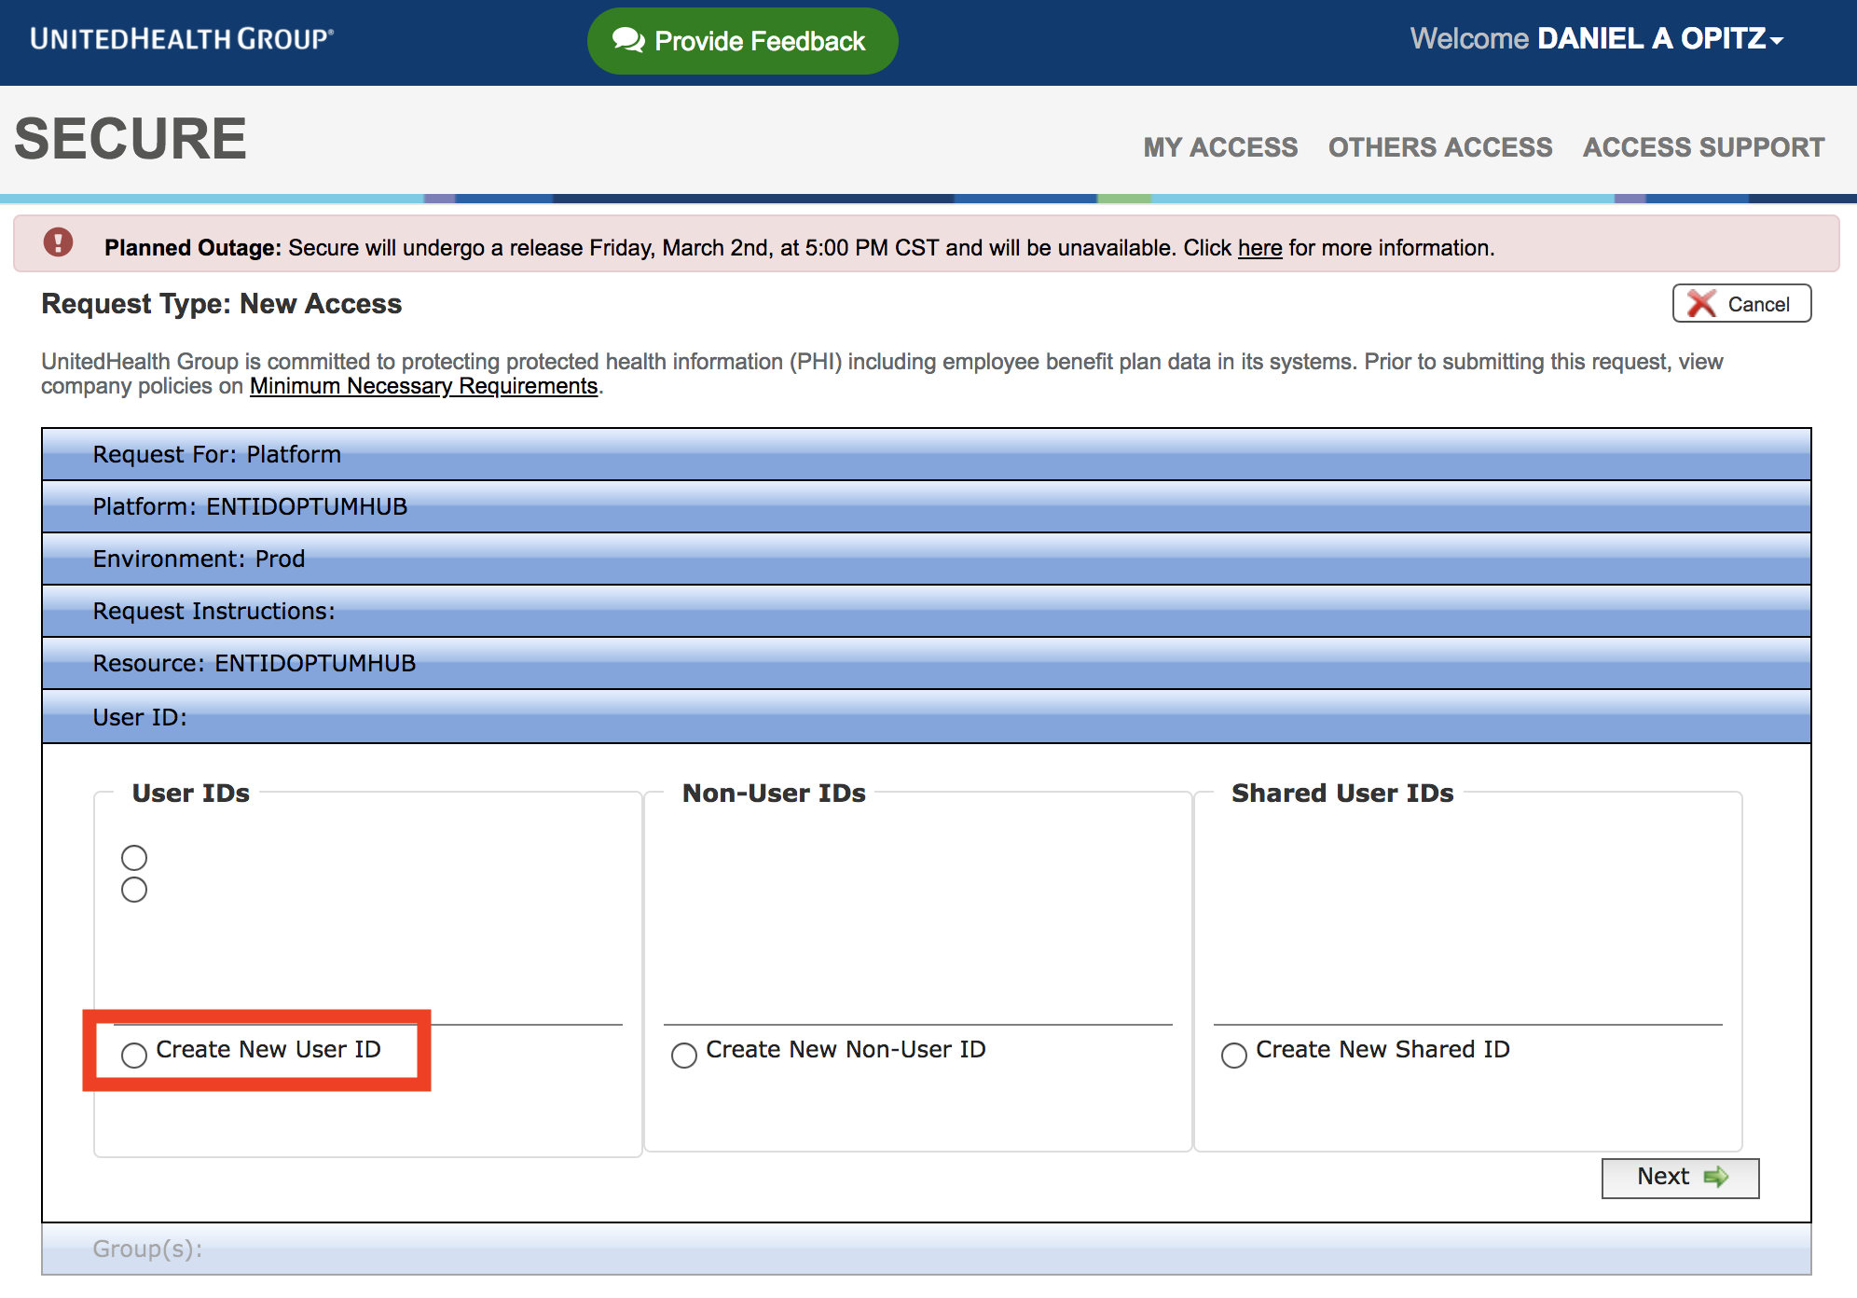
* There is no need to add any Group access at this point.
* Fill in your Business Justification for requesting your User ID.
* Submit the Secure Request.

Note: You must create your Primary User ID first and complete the request, and then go through the process again to create your Secondary User ID and complete the request. Please wait at least 4 hours before attempting to sign in as an RSA sync is occurring behind the scenes.

This is how you create ENTIDOPTUMHUB User IDs. It is the same process for both however the User ID will differ by one character/number.

**Request Global Group Membership to Your Subscription**

Note: If you are following this guide to set up your DCE account, you **DO NOT** need to complete this section. Please skip and continue to [accessing the portal](https://commercialcloud.optum.com/docs/getting-started/access-azure-portal/#access-the-portal).

*Once your subscription is provisioned*, you can request membership to your *Secondary ENTID* AD global groups that control access to your subscription. You can also direct your team members to do so.

**Note**: Two groups are created for your subscription, _Owner and _Contributor. The groups are mapped to Azure's built-in roles named the same. We recommend only a select few having _Owner access per subscription. **These groups are unique to your subscription**.

* Click on *Secure Home Page > My Access > Request New Access* and fill out the form as shown below: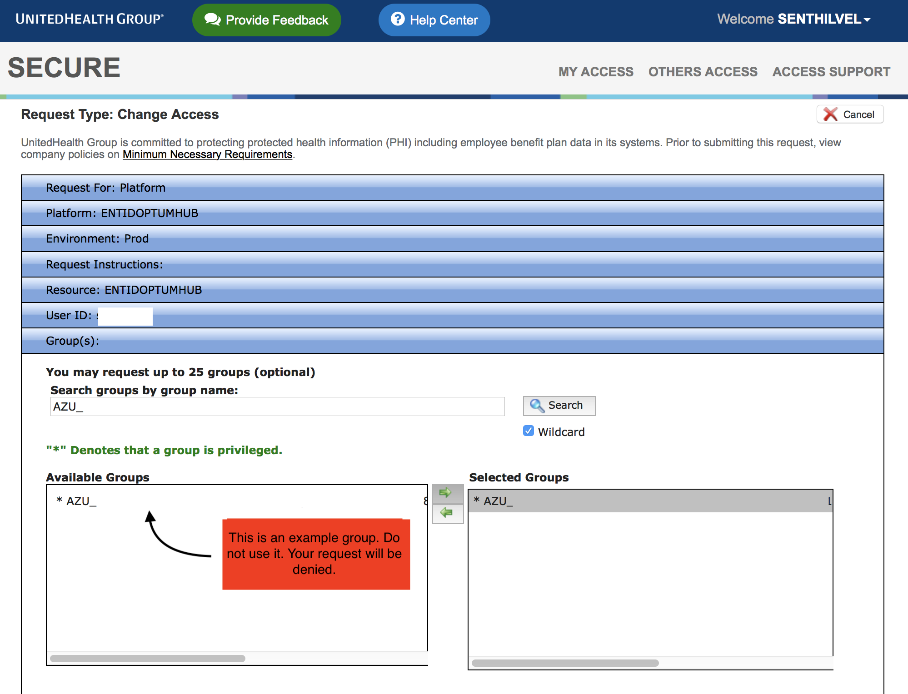
* Provide business justification and submit the request.

**NOTE**: You can create additional built-in or custom Azure roles as necessary. Once the groups are present in Secure, team members can request membership as needed. Please see [this guide](https://github.optum.com/dhoude/Guides/blob/master/AzureSecureGroup.md) for set up instructions.

**Access the Portal**

After finishing the above steps, allow for ~3 hours to pass for RSA to properly sync with your secondary ENTID prior to logging into Azure.

* Navigate to [https://portal.azure.com](https://portal.azure.com/).
  + If you have multiple Azure user accounts, you will be presented with the *Pick an account* dialog. Choose the *Use another account* option, when you login with this account for the first time.
* This will redirect you to *Sign in to Microsoft Azure* dialog. Here, enter your **Secondary ENTIDOPTUMHUB User ID** followed by the *entid.optumhub.net* domain as shown below and click *Next*.
  + *<your-entid-secondary-id>@entid.optumhub.net*
  + Example: [*sthang15@entid.optumhub.net*](mailto:sthang15@entid.optumhub.net)
* You will be taken to **SecureID Login** page. On this page, enter the *same* secondary ENTID login and your RSA token
  + **ENTID SECONDARY UPN**
    - *<your-entid-secondary-id>@entid.optumhub.net
  + **PIN+TOKEN**
    - If you have **RSA Hard Token**, enter your Pin + RSA token code.
    - If you have **RSA Soft Token**, enter the RSA token code.
* Click *Login* to sign in to Azure.

**Troubleshooting**

* ***We didn't recognize the ENTID or Pin+Token you entered. Please try again.***

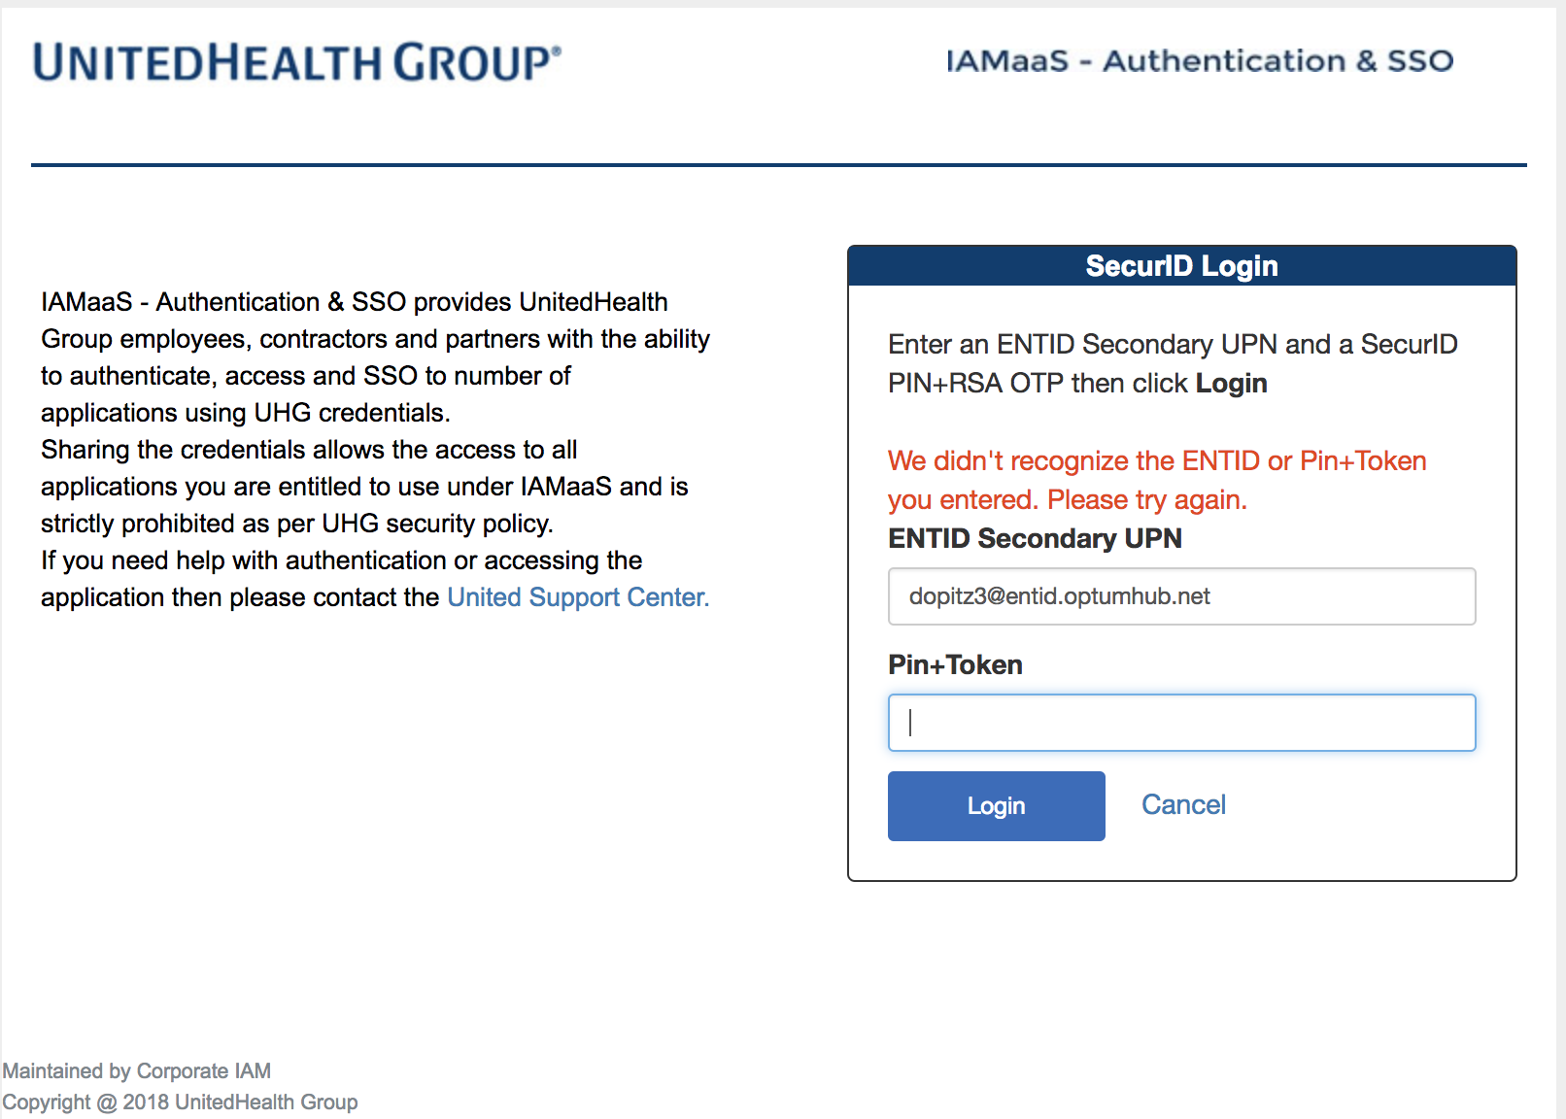

* + Check that you are entering your correct UPN (*<your-entid-secondary-id>@entid.optumhub.net*).
  + Check that you are entering just your token (No Pin) if you are using a Soft Token.
  + Check that you are entering your Pin+Token if you are using a Hard Token.
  + Check that your MS ID was succesfully added to the AzureAccess Global Group.
  + If you have multiple secondary ENTID's, use your primary secondary ENTID. Additional secondary ENTID's do not have RSA authentication access.
* ***SAML response does not contain assertion element.***

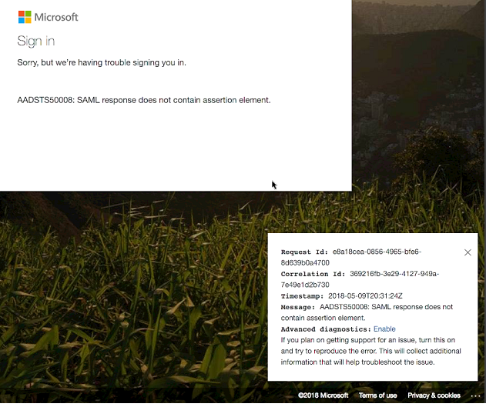

* + This error usually indicates the username (UPN) entered doesn't match with any identity that has been synced with Azure.
  + Wait 30 Minutes to allow for a sync to occur and try again.
  + If you still recieve the error be sure that you created the Secondary ID in the correct domain (ENTIDOPTUMHUB).
* ***How do I check if I have a primary and/or secondary ENTID created?***
  + In [Secure](https://secure.uhc.com/) click the "View" button under current access.  
    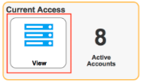
  + Click "Clear" in the top right corner. If you have IDs associated with the ENTID domain they will appear as shown below. 